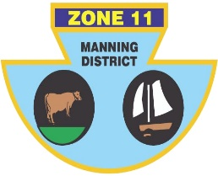
ZONE ll (MANNING DISTRICT)
BOWLING ASSOCIATION INC
PO Box 100 Old Bar 2430 Phone 02 6553 3330 ABN: 21 505 810 214

The following players have been selected to represent Zone 11 in the John Smith Shield against Zones 2, 15 and 6 at East Cessnock B/C on Saturday and Sunday the 16th and 17th January, 2021.

SKIP | Rex JOHNSTON (TB) | Shane GLOBITS(BH)
THIRD | Steve PELL (F) | Jason AURISCH (TB)
SECOND | Peter SCHROEDER (F) | Ash BRYMER(TB)
LEAD | Noel JAMES(TB) | Kris MURTAGH(TB)

SKIP | Martin GOSPER(F) | Shannon White(F)
THIRD | Matt PEARCE (H) | Daniel JESSOP(SP)
SECOND | Peter CASSAR (H) | Ashley HINTON (TW)
LEAD | Warren COCKSEDGE (TL) | Trevor COSTA (H)

Reserves), Nathan Butler, Malachy McTaggart, Jason Cassidy, Mark Boyd
MANAGER/RESERVE: Errol RUPRECHT (TW)
PROGRAM: Saturday – Two games of 21 ends commencing at 10 a.m. and 1.00 p.m. Sunday - One game of 21 ends commencing at 9.00 a.m.
Meals: Breakfast Sunday and lunch Both days will be provided East Cessnock Bowling Club.
TRANSPORT: Skippers/players to arrange their own transport.
ACCOMODATION: Cessnock Vintage Motor Inn
IF YOU ARE UNAVAILABLE PLEASE ADVISE SHANNON WHITE ASAP ON 0431450168

