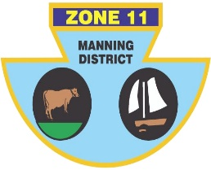
ZONE ll (MANNING DISTRICT)
BOWLING ASSOCIATION INC
PO Box 358 , Taree 2430 Phone 02 6553 3330 ABN: 21 505 810 214

Congratulations, you have been selected to represent Zone 11 in the Open side at the Inter-Zone Sides Championships to be held at South Tamworth from the 20th to 22th May.

 | TEAM 1 | TEAM 2 | TEAM 3
LEAD | Matt PEARCE (H) | Damian Pennings (TL) | Warren COCKSEDGE (TL)
SECOND | Peter CASSAR (H) | Justin Costa (W) | Brett English(BH)
THIRD | Keeden McGuire (F) | Erin Smith (F) | Jason AURISCH (TB)
SKIP | Shannon WHITE (F) | Martin GOSPER (F) | Shane Globits(BH)

Reserve: Craig COLLIGAN (H) J Cassidy (G)

MANAGER: Shannon White

TRAVEL: Players to arrange their own transport, to arrive on the Wednesdsay 19th May.

VENUE: Section play and finals at South Tamworth BC commencing on the 20th May at 8.30am.

ROLL-UP: At South Tamworth BC on the 19th May Time TBC.

ACCOMODATION: . The cost per player is TBC for the three nights accommodation, payable to Zone 11 Manning District Bowling Association via EFT to
BSB 062 540, Acc. No. 10273918.

Room allocations are as follows:
Pearce and Cassar, Mcguire and White, Pennings and Cocksedge, Costa and English, Aurisch and Globits, Smith and Gosper.

MEALS: Breakfast and lunch will be provided by the Zone. All evening meals will be at the players expense.

IF YOU ARE UNAVAILABLE PLEASE CONTACT Shannon White, 0431450168, ASAP.

Noel James
Chairman of Selectors

