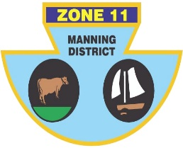
ZONE ll (MANNING DISTRICT)
BOWLING ASSOCIATION INC
PO Box 358 , Taree 2430 Phone 02 6553 3330 ABN: 21 505 810 214

Congratulations, you have been selected to represent Zone 11 in the Dooker/Eggart Shield, against Zone 14, on Sunday 8th March, 2020.

OPEN
LEAD | Matt PEARCE (H) | Trevor COSTA (H) | Kris MURTAGH (TB)
SECOND | Peter CASSAR (H) | Nathan BUTLER (TL) | Tom MOORE (W)
THIRD | Martin GOSPER (F) | Warren COCKSEDGE (TL) | Jason AURISCH (TB)
SKIP | Shannon WHITE (F) | Ashley HINTON (CWB) | Dominic RILEY (CWB)

Reserve: Steve MATHESON (W), Craig COLLIGAN (H)

SENIORS
LEAD | Bob O’MAHONY (CWB) | Tony HINTON (CWB) | Robert AUSTIN (TL)
SECOND | Barry DIXON (F) | Grant McKIRDY (TB) | Errol RUPRECHT (CWB)
THIRD | Noel JAMES (TB) | Dave RICHARDSON (TB) | Geoff PELL (F)
SKIP | Steve HARRIS (TB) | Rex JOHNSTON (TB) | Peter SCHROEDER (F)

Reserve: Terry MALONEY (H)
Manager: Harry Williams
Venue: Wauchope Country Club, 24 King St Wauchope
Program: 2 games of 18 ends, commencing at 9.00 a.m. Players to arrive no later than 8.15 a.m. Lunch will be provided.
Transport: Players to arrange own transport.
IF YOU ARE UNAVAILABLE PLEASE CONTACT NOEL JAMES ASAP ON 0421278806

Noel James
Chairman of Selectors

